Lizeth Campos

Lab 6 Graphs

Introduction

In this Lab we were asked to implement some graph algorithms in other words we have to implement the following algorithms: Kruskal’s algorithm and topological sort. Graphs can be connected through items or nodes that connect with vertices.

Proposed implementation

For the first implementation I’m going to be talking about is the Kruskal’s algorithm, in this algorithm I have my Kruskal’s class following by a series of different methods like the add Edge method which appends or adds edges to the graph another method is the Find method finds the original. For the Topological Sort has three different methods for example the Add Edge as same as the other just adds the edges to the graph the topological Sort Util which marks the visited nodes.

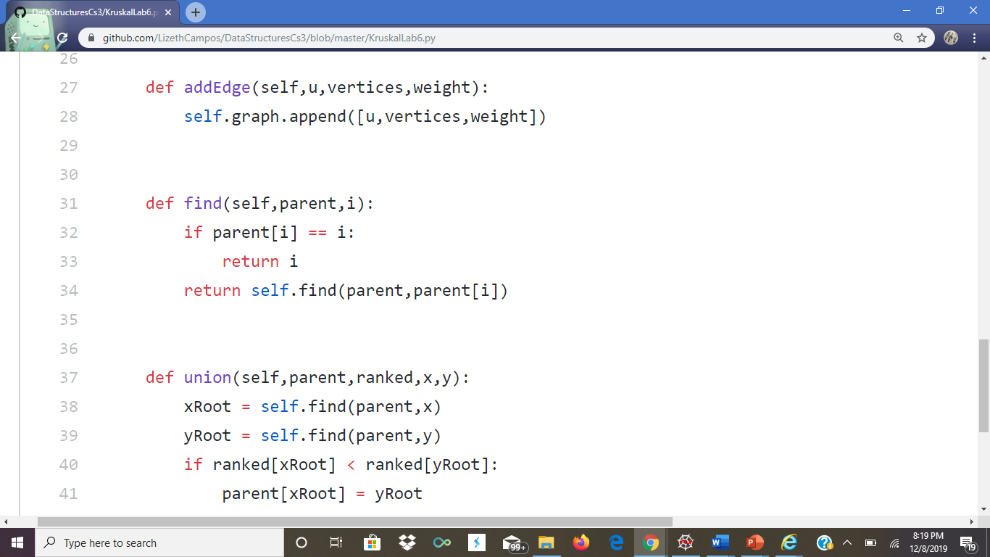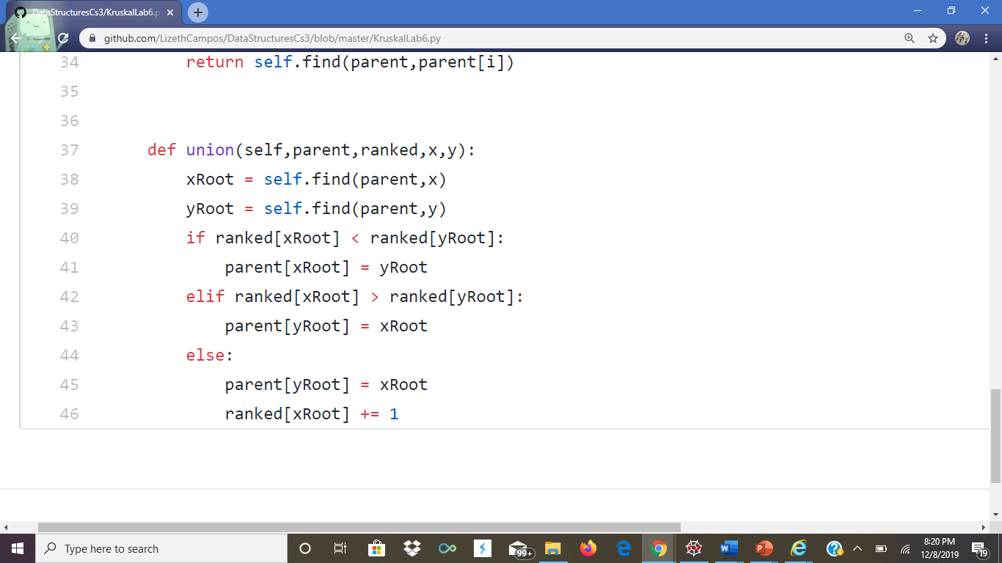

Experimental Results

Some of the different Test cases I tried with this Was trying different Weights for the graph. Another thing I also tried to do was Try different sizes and different weights with my algorithms.

Conclusion

Trying different sizes with your algorithms helps get a better understanding of what you are doing and also it also helps to have different weights for them just to see how watch perform or in other words see what the result of each might be,